|  |  |
| --- | --- |
| Purpose | Establishes a standard procedure for setting up and interacting with the R&D keyboard input automation devices. Multiple microcontrollers are capable of forming a wireless mesh network that transmits keystrokes to one, multiple, or all devices simultaneously. |
| Scope | This document applies to facilities in R&D and manufacturing that desire automated keystroke entry for the remote operation of many devices. |

### 

1. **References**

|  |
| --- |
| **Regulations and Standards** |
| Code of Federal Regulations 21CFR §211 |
| Code of Federal Regulations 21CFR §820 |
| Health Canada - Medical Device Regulations (MDR) |
| Medical Device Directive 93/42/EEC |
| Japanese Pharmaceutical Affairs Law |
| ISO 13485: Quality System Regulatory Requirements forMedical Devices |

NOTE: the documents referenced above are shown without revision levels, unless specified, the most current version applies.

|  |  |
| --- | --- |
| Document | Document Number |
| N/A | N/A |

**2.0 Definitions**

|  |  |
| --- | --- |
| Term | Definition |
| ESP32-S3 USB-OTG | Microcontroller |

Haemonetics Dictionary………………………………………………………………………………………………….SOP02.00

# Applicable Forms

No forms are required for the use of this process

# Responsibilities

The following section establishes roles and responsibilities for this Process.

|  |  |
| --- | --- |
| Role | Responsibilities |
| The Biomedical Laboratory Director or designee | Responsible for the administration of this procedure |
| The Laboratory Director or designees | Responsible for the implementation of this procedure and for assuring that training is provided to all affected personnel. |
| The Laboratory Staff | Performing the tasks shall be responsible for following all appropriate procedures pertaining to their job and informing the manager of any discrepancies during execution. |

# Process:

## Material and Equipment

### ESP32-S3 USB-OTG microcontroller (ESPRESSIF systems)

### 1.5 ft USB male to female (required for each TEG6S due to physical space limitations)

### Micro-usb to USB cable for connection to computer (Important: Low quality power only micro-usb cables will not work as they do not allow data transmission)

### Computer/laptop with USB to serial capability (alternatively a virtual com port can be used by installing the “CP210x USB-to-UART with serial enumeration” driver from silicon labs)

### Arduino IDE or other software with serial monitor/communication capability

## Instruction for routine operation

### Connect multiple microcontrollers using the USB DEV port. This port is used for sending keystrokes to the connected device in addition to supplying power. Multiple devices will automatically connect to one another and form a wireless ad-hoc mesh network (no server or router required). A yellow light is displayed if the device is not yet connected. The number of connected devices in the network is displayed on the screen under “Node Count: X” with X = number of devices. The blinking green light indicates how many devices are in the network. Example: blinks 3 times when 3 devices are connected.

### If no other devices are in range, or there is a problem with the system, a failsafe is triggered and the device is restarted automatically. Connection will be re-attempted automatically. Devices that are not connected to the mesh network will display a solid yellow LED.

### Use the “UP+” to transmit the pre-programmed username to all devices in the network.

### Use the “DW-” to transmit the pre-programmed password to all devices in the network.

### Two methods are available for transmission of custom messages.

### C:\Users\vdigiovanni\AppData\Local\Microsoft\Windows\INetCache\Content.Outlook\NL2PGBKC\IMG_5394.jpgMethod 1: load a micro SD card with a file named “patientID.txt”. Insert the micro SD card to the device. To transmit the message, press the “BOOT/OK” button on the device.

### Method 2: It is recommended to setup a dedicated station to use the devices as virtual keyboards and broadcast custom messages. To achieve this, connect one of the devices to a computer capable of serial communication using the USB-UART0 port on the microcontroller. A micro-usb cable with both power and data transmission capability is required for this connection.

#### C:\Users\vdigiovanni\Pictures\board menu.PNGInstall/open the Arduino IDE. From the top menu bar, select the board type by “Tools -> Board -> ESP-32 -> ESP32-S3 USB OTG”

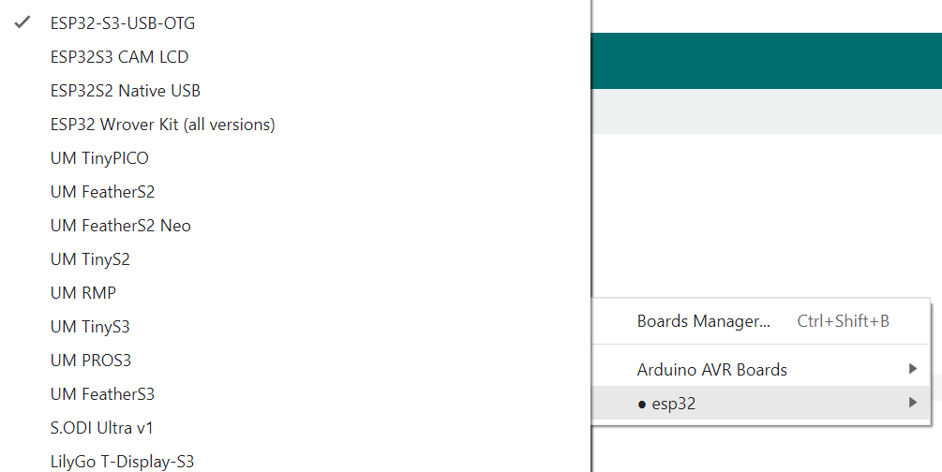

#### Select the port the device is connected to. From the top menu bar, select the port by “Tools -> Port -> COM3”

#### C:\Users\vdigiovanni\Pictures\select a COM port.PNG

#### Arduino IDE has a serial monitor application, start this application. From the top menu bar, select the serial monitor application “Tools -> Serial Monitor”

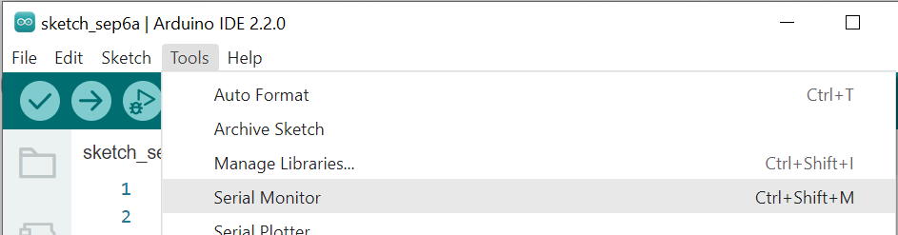

#### The microcontroller will listen for text sent using the serial monitor application and broadcast it to the rest of the devices in the network. Use the “enter” key to transmit the text only. If the serial monitor settings are set to “no line ending” Pressing the enter key to send the text will transmit only the text. Changing this setting to “carriage return” will append the “enter key” function at the end of the text line.

#### C:\Users\vdigiovanni\Pictures\text entry.PNG

### Each device has a unique “DeviceID: 0XX” displayed on the screen, this ID can be placed directly before a message and the message will be transmitted to that device only. Example: “test -> 010test” sending the “010test” will send “test” to the device with “DeviceID: 010” displayed.

### NOTE: text to be sent should not contain a zero at the beginning unless it is a device ID as they will fail to transmit.

### Messages sent over the serial monitor without a leading zero will be broadcast to the entire network. Example: “testing all devices” will send “testing all devices” to all devices connected to the network.

### To send a message to several specific devices, add the deviceID to the front of the text to be sent. Separate each using a comma. Example: “001test A,002test A,005test B,010test B” will send “test A” to devices 001 and 002. Devices 005 and 010 will receive “test B”.

### To check if a device is receiving messages, the display contains a list of the most recent messages.

### Press the menu button to change the device ID

|  |  |
| --- | --- |
| Document | Document Title |
|  |  |

# Revision History

Please consult the Document Management system for the revision history.